For templates you have to make a computer class that can do the 4 basic operations add, subtract, multiply, division. Bonus: Extend the calculator to support complex numbers (a complex number is a pair of 2 numbers, one representing the real part and one the imaginary part)

The red i basically tells you that that is the imaginary part, so if your structure is:

struct NoComplex

{

actual float;

imaginary float;

}

then for x + yi in the diagram you will have real = x, imaginary = y

2

if it's complicated with the class, you can only make global functions

1

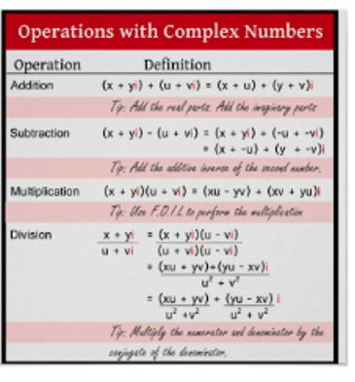as a bonus, don't overwrite the operation operators, basically what I want is to specialize the template